**CENWP-OD-BCL 21 April 2023**

**MEMORANDUM FOR THE RECORD**

**SUBJECT: 23BCL01 Circuit Breaker Outage**

**Description of the problem:**

On the afternoon of April 19, 2023, at 1304, circuit breaker XJ31 at Big Cliff project was tripped due to a ground fault, causing an unplanned unit outage. Currently Big Cliff project is able to generate power, however it is not able to distribute power out of Big Cliff project.

**Type of event:**

Turbine unit outage.

**Impact on facility operations:**

Flows temporally increased from 1250 cfs to 1750 cfs before returning to approximately 1250 cfs. Total dissolved gas (TDG’s) increased from 101% to 122% and remains elevated at approximately 117%, above the ODEQ limit of 110%. Big Cliff project is not currently able to transmit power and is operating outside of BiOp criteria.

**Expected impacts to fish:**

Impacts to ESA listed species are expected to be minimal. To date, less than 20 Winter Steelhead have been placed above Minto Fish Facility. No adult Spring Chinook have returned to Minto and all juvenile smolts have been released from the facility. Wild juvenile Chinook are well past the most vulnerable life stages.

**Corrective Actions:**

The cause of the fault was found in the 13.8KV bus work outside the DET powerhouse between XJ31 and the DET/BCL line disconnect at 2000hrs on 21 April 2023. Repair work is ongoing, the next update will be provided no later than 27 April 2023.

**Comments from agencies:**

Please email with questions or concerns, thank you.

Robert H. Wertheimer [robert.h.wertheimer@usace.army.mil](mailto:robert.h.wertheimer@usace.army.mil)

Portland District - Supervisor, Fish Field Unit (FFU).

541 374-3651

FFU Main: 541 374-8801

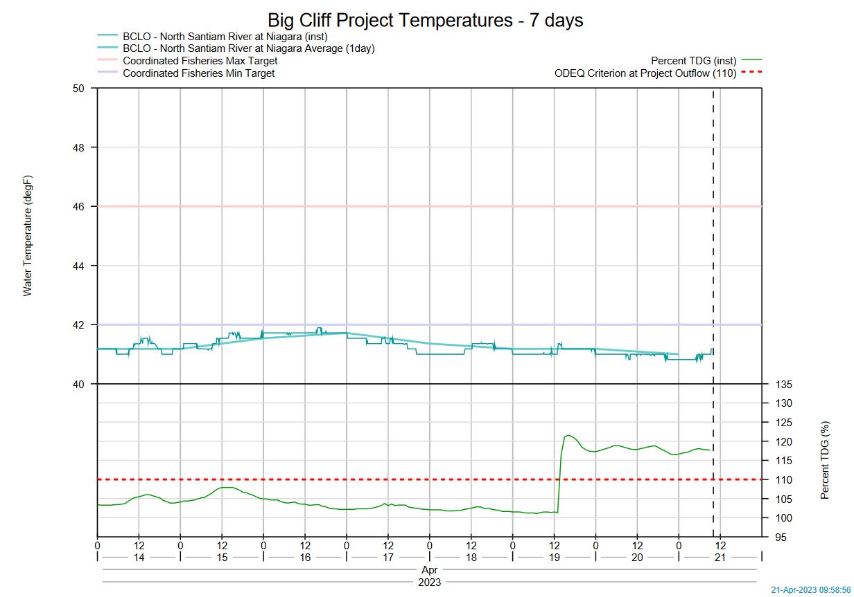

Fig 1. While temperatures have remained consistent, TDG’s have remained elevated above the 110% limit.

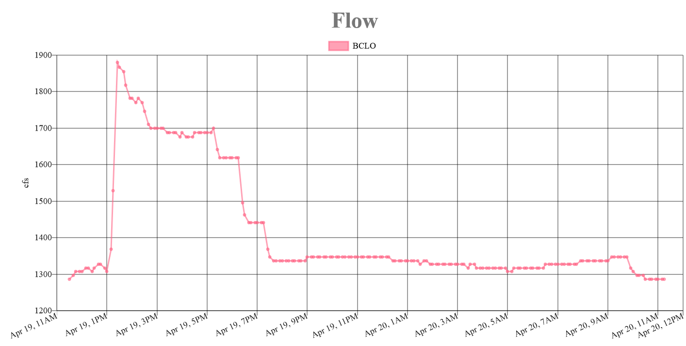

Fig 2. The increase in flow from Big Cliff project seen on 19 April before returning to normal.

Sincerely,

Project Fisheries